Project 7-1: Change Calculator

User interface
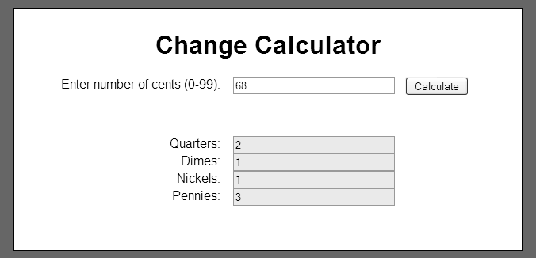

Operation
- This application allows the user to enter a number of cents from 0 to 99.
- This application displays the minimum number of quarters, dimes, nickels, and pennies that represent the coins that make up the specified number of cents.

Specifications
- Assume that the user will enter a valid integer for the number of cents.

